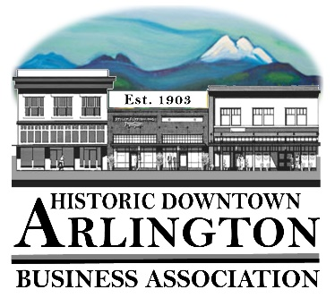
Downtown Arlington Business Association Board Meeting Agenda
February 15, 2018
5:15 – 6:15 pm
Location: Olympic Escrow

- Board Quorum verified and Meeting Called to Order
- Approval of Board Meeting Minutes Held January 16, 2018
- Communication, Meeting Schedules etc.,
  - General –
    - Member Meeting March 7, 2018– Draft Agenda Attached
    - Meetings with the Mayor – Reminder next meeting Wednesday, February 21 @ 3:30
    - Mainstreet Conference Port Townsend – April 22-25, 2018
    - Member Meetings – discussion of need to make sure there is a quorum of members and/or a quorum of the Board for these meetings.
    - Downtown Pocket Park – Discussion
- New Business:
  - 2018 Budget Updated Draft – Treasurer will distribute updated 2018 Budget and explain recommended changes
- Old Business:
  - Giving/Funding Committee
- Event/Project Reports:
  - Viking Fest
  - 530 Media Board
  - EagleFest 2018 – Need to include in 2019 LTAC Grant Applications
  - Car Show 2018 - Car Show Ad in Cruizin Magazine $285.00
  - Street Fair 2018
- Treasurer/Administrator Report
  - Bank Account
  - Membership –
  - 2018 LTAC Grants Status
  - Request for approval on –
    - Friends of the Library Lifetime Membership
    - Youth Dynamics Sponsorship
    - Arts Council Membership
- Miscellaneous
- Next Board Meeting – March 15 10. Adjourn

