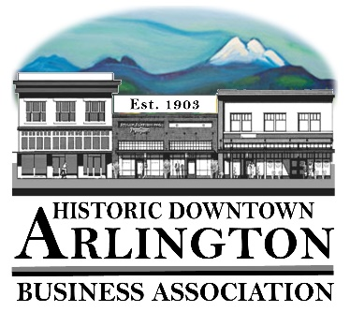
Downtown Arlington Business Association Board Meeting Minutes
May 16, 2019
9:00 – 10:00 AM
Location: Stilly Cooperative

Board meeting called to order at 5:57 PM
Board members in attendance: Cristy, Mike, Bill, Tina, Rich, & Lisa No guests.

Motion to approve prior board meeting minutes from 3/21. Rich seconded by Bill. All ayes.

Communication, Meeting Schedules etc.,
· Main Street Meeting - 5/21
· Discussed redoing brochure and touching base with businesses.
· Member Meeting Draft Agenda - June 5th - Mike will not be there - on vacation.
· Next board meeting June 20th. Thursday evening at 6pm.

New Business:
· Cristy motioned that we sponsor the 4th of July parade at the Blue - $500 level. Seconded by Tina.

Old Business:

EVENTS:
- AARON CRAWFORD SUMMER KICKOFF
· Need to create an event for the Aaron Crawford Kickoff Event on our Facebook page.
· Lisa spoke to Maury about radio advertising. Stitch would be here for introduction the night of the event.
· Sound people we talked to for Aaron Crawford event not communicating. Aaron Crawford advised his sound guys will do the same price as the other guys.
· Windermere, Caliber Home Loans sponsoring. Still working on other sponsors, shooting for $1000 more.
· Banners through Office Depot are cheap, and super-fast (sounds like Same Day for Chamber banner ordered today.)
· Discussed $50 vendor fees for food trucks for the Aaron Crawford event.
· Ordering a couple boxes of glowsticks for events.
- CAR SHOW
· 53 cars registered. Had 44 this time last year.
· Sponsorships currently at $10,695
· Ads done; posters ready to go.
- STREET FAIR
· Taken in $18000 or so thus far.
· Discussed potentially raising prices for booths next year since we have so much interest this year.

TREASURER REPORT
· $32,900
· Membership count over 100, no accurate count this moment.
· Going to work on increasing the participation for the 530 board.

Meet concluded at 7:20 PM.

Mike Bradley - Secretary

