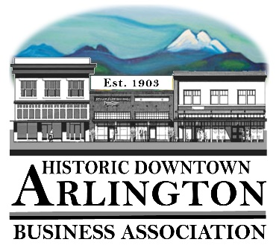
Downtown Arlington Business Association Board Meeting Agenda
Sept. 20,2018
5:30 pm
Location: Olympic Escrow

- Board Quorum verified and Meeting Called to Order
( Lisa ___Tina____Brandon___Cristy___Bill___Rich___)
Guests:

- Approval of Board Meeting Minutes Held August 15, 2018
Motion to Approve Minutes of the August 15, 2018 by_______ Seconded_____ All in Favor _____
- Communication, Meeting Schedules etc.,
    - Mainstreet Meeting –Sept. 25 @ 11:30
    - Chamber Board Meeting – 7:30AM September 25
    - Member Meeting – October 3, 2018 – Draft Agenda Attached (Raffle Items? – Art Auction Tickets & ? We could have two buckets to draw from – one for the art auction and one for another mug with candy……..)
    - October 20 – Fall into Art Auction - Tickets are $40 each – will be purchasing 6 tickets and drawing for winners at the October 3rd Member Meeting – (Cristy will be there to help Jen with the auction)
- New Business:
  - Arlington Co-Working Space Update and discussion of how DABA will participate.
  - 2018 LTAC Reimbursements
  - 2019 LTAC Grants – Approval to submit for LTAC Grants
    - Street Fair – Advertising & Street Entertainment
    - Car Show – Advertising & Entertainment (Maybe add Radio like Street Fair Had)
    - Brochure – 2019 Distribution Costs and update in fall of 2019. Printing and Distribution in 2020
    - Hometown Holidays 2019– Entertainment (Wagon Rides, Music??) & Advertising – Maybe add Radio Station?
    - Eagle Festival 2019 – Wagon Rides for 1-day Event? Charm walk?
  - 2019 Elections – Appoint Elections Person
  - 2018 Budget Reports YTD
  - 2019 Budget Draft

- Old Business:
  - Sound System -
Notes:

- Event/Project Reports:
  - 530 Media Board- Notes:

  - Car Show 2019– June 7/8

  - Street Fair 2019- July 12/13/14 – Kornstalk will be a part of the event – so that takes care of entertainment for Friday and Saturday. We need to talk with Sarah about Sunday – perhaps that would be a good day for the Voices of the Village and the Old Time Fiddlers.

  - A Night on the Town 2019 – August 9 – City will be having entertainment in the park that night – so this event would just be marketing, staying open late and food vendors. Perhaps Farmers Market people would be willing to set up the night before?

  - Welcome Drag Strip Reunion Friday Sept. 6 – If they decide to have the Drag Strip Reunion again in 2019 – DABA should help promote it and be open late that Friday Night as people are in town and cruising around. Also need to get some of our downtown brochures out to these events.

  - Harvest Festival 2019– September 13/14 (Chamber Event)

  - Hometown Halloween 2018 – October 27

  - Hometown Holidays – Kick off on November 24th with Shop Local/Holiday Open House and Tree Lighting. Santa Parade & Wagon Rides December 1 and then Wagon Rides December 8,15 & 22. (waiting to hear from Cramer on whether they are able to provide wagon rides the 4 weekends) We will be having a Hometown Holiday Meeting Soon.)

- Treasurer/Administrator Report
  - Bank Account
  - Membership –

- Miscellaneous

Next Board Meeting –
Adjourn

