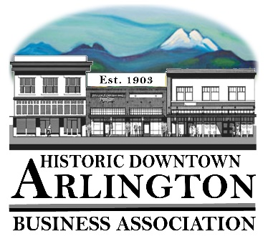
Downtown Arlington Business Association Board Meeting Agenda
November 15, 2018
5:30 pm
Location: Stilly Cooperative

- Board Quorum verified and Meeting Called to Order
( Lisa ___Tina____Brandon___Cristy___Bill___Rich___)
Guests:
- Approval of Board Meeting Minutes Held October 18, 2018
Motion to Approve Minutes of the October 18, 2018 by_______ Seconded_____ All in Favor _____
- Communication, Meeting Schedules etc.,
    - Mainstreet Meeting –next meeting is November 20th
    - Member Meeting – December 5– Draft Agenda attached for approval and do we want refreshments.
    - December Board Meeting – Invite past board members, new board members and spouses – December 20th? Where?
    - Brief look at 2019 Calendar – Attached.

- New Business:
  - 2019 LTAC Grants –
  - 2018 Budget Reports YTD
  - 2019 Budget Draft
- Old Business:
- Event/Project Reports:
  - Hometown Holidays – Kick off on November 24th with Shop Local/Holiday Open House and Tree Lighting. Santa Parade & Wagon Rides December 1 and then Wagon Rides December 8,15 & 22.
- Treasurer/Administrator Report
  - Bank Account
  - Membership –
- Miscellaneous

Next Board Meeting – December 20th
Adjourn

