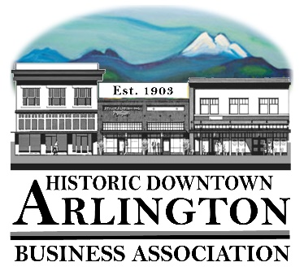
Downtown Arlington Business Association Board Meeting Agenda
April 19, 2018
5:15 – 6:15 pm
Location: Olympic Escrow

- Board Quorum verified and Meeting Called to Order
( Lisa ___Kathleen___Jammi___Cristy___Bill___Rich___)
Guests:

- Approval of Board Meeting Minutes Held March 15, 2018
Motion to Approve Minutes of the March 15, 2018 by_______ Seconded_____ All in Favor _____
- Communication, Meeting Schedules etc.,
    - Member Meeting May 2, 2018– Draft Agenda Attached
Agenda Approved for May 2 meeting as is or with changes –
Notes:

    - Mainstreet Meeting – Reminder next meeting Wednesday, May 9 @ 3:30
Notes:

    - Mainstreet Conference Port Townsend – April 22-25, 2018

- New Business:
  - Band Booster at Wild Rose Bistro April 18, 2018 - discussion
Notes:

- Old Business:
Notes:

- Event/Project Reports:
  - 530 Media Board
Notes:

  - Car Show 2018 –
Notes:

  - Street Fair 2018
Notes:

- Treasurer/Administrator Report
  - Bank Account
  - Membership –

- Miscellaneous

Next Board Meeting – May 17
Adjourn

