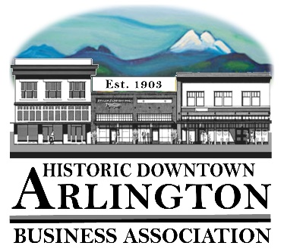
Downtown Arlington Business Association Board Meeting Agenda
June 20, 2018
5:15 – 6:15 pm
Location: Olympic Escrow

- Board Quorum verified and Meeting Called to Order
( Lisa ___Tina____Brandon___Cristy___Bill___Rich___)
Guests:

- Approval of Board Meeting Minutes Held May 22, 2018
Motion to Approve Minutes of the May 22, 2018 by_______ Seconded_____ All in Favor _____
- Communication, Meeting Schedules etc.,
    - Member Meeting July 11– Draft Agenda Attached
Agenda Approved for July 11 meeting as is or with changes –
Notes:

    - Mainstreet Meeting –cancelled for June

- New Business:
  - Presentation of updated Sponsorship/Giving Committee Form and Brief Discussion of process.
  - Snohomish County Tourism Think Tank – Stillaguamish-Sauk River Valleys –Arlington Boys & Girls CLub– June 19, 2018 9AM to 4PM

- Old Business:
Notes:

- Event/Project Reports:
  - 530 Media Board
Notes:

  - Car Show 2018 –
Notes:

  - Street Fair 2018
Notes:

- Treasurer/Administrator Report
  - Bank Account
  - Membership –

- Miscellaneous

Next Board Meeting – July 19
Adjourn

