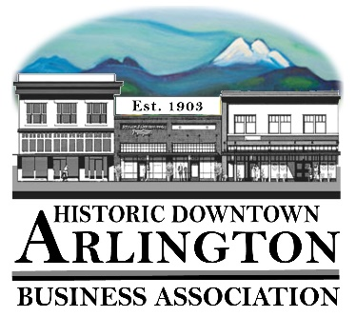
Downtown Arlington Business Association Board Meeting Agenda
July 19, 2019
6PM
Location: Action Sports

- Board Quorum verified and Meeting Called to Order ( Lisa ___Tina____Mike___Cristy___Bill___Rich___)
Guests: Will Nelson, director of equity and student success for Arlington Public Schools. Will is planning on doing some awesome work in our community focused around equity and diversity and would like DABA to participate.
- Approval of Board Meeting Minutes Held May 16, 2019
Motion to Approve Minutes by_______ Seconded_____ All in Favor _____
- Communication, Meeting Schedules etc.,
    - Mainstreet Meeting- June report and July Meeting was cancelled
    - Member Meeting – August 7, 2019
    - Next Board Meeting – August 15, 2019
- New Business:
  - 2020 Elections -
- Old Business:
- Event/Project Reports:
- August 16, 2019 Hot August Nights – Friday Night Businesses stay open late, Music in the Park and Beer Garden?
- Aaron Crawford Summer Kick Off Concert
- Car Show
- Street Fair
- Brochure
- Treasurer/Administrator Report
- Bank Account $16,573.58
- Membership & Accounts Receivables – Cristy will be working on this next as we have some people that need reminder invoices.
- 2019 Budget – Budget Report, Car Show Budget Report and Street Fair Budget Report
- LTAC Grant Applications - Someone on the Committee? Applications for – Brochure, Car Show, Street Fair, Summer Kick-Off, Anything Else?
- Insurance Costs – Cristy will be meeting with Jen and the Insurance Company on Wednesday and will report back on costs etc.
- Marketing Items – Fans, Bags and Hand Sanitizer
- 530 Board
- Member Meeting Raffles – ask that members bring something to raffle?
- Miscellaneous

Next Board Meeting – August 15, 2019
Adjourn

