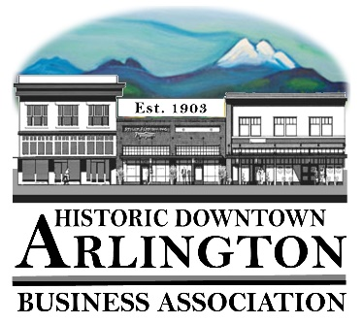
Downtown Arlington Business Association Board Meeting Minutes
July 18, 2019
6PM
Location: Action Sports

Board members in attendance: Lisa, Tina, Cristy, Mike, Rich, Bill

Meeting called to order at 6:04.

Guest: Will Nelson, did not end up coming. Sent email to Lisa, which she read to board. Discussed reaching out to him and getting more information and suggested "other" DABA members be asked to participate outside of the board.

Approval of previous minutes. Rich approved; Bill seconded.

Tina shared a potential future "Mainstreet Storefront" company she will reach out to see if they would be willing to do an event in Arlington.

Member Meeting August 7th, 2019.

Discussed trying to get Arlington Hardware management staff involved.

Discussed potential for Stay Open Til' 8 nights (hoping to ask Suzi to "champion" the idea and get involved with that specific event.)

Next Board Meeting August 15th, 2019. At Action Sports.

New Business:

2020 Elections - Jeri is interested in being "Treasurer." Idea is that Cristy would move to Admin. To discuss further in August.

August 16th - Hot August Nights - No Chamber Beer garden since band (Waking Maya) will be done by 8pm or so. DABA not doing a special event for this night.

Suggested for next year reaching out to some of the KISW Battle of the Bands bands. Klover Jane, Jar of Flies, Windowpane

Aaron Crawford Event / Summer Kickoff - possibly a Saturday next year, and potentially multiple bands, and make a day of it. If DABA is paying for the Band, DABA should have a stake in the Beer Garden.

Discussed at length "better next year" ideas, and issues with this year’s event, and certain folks stepping on toes with planning.

Street Fair:

Drawing:
3rd: $50 gift card to Moe's: Val Lyon
2nd: $100 Arlington Hardware Gift Card: Linda St. Onge
1st: Night at Angel of the Winds: Dan Spencer

One Vendor didn't show up.

A few left early. Sassafras, Sno Co Headstart, St. Andrews, Lizzy's Green Attic, Lance Otto and Assoc., and Gooder N' Chicken.

A few new ideas.
• Street performer should be "mobile" and NOT stationary.
• Website for taking Credit Cards setup for Car Show and Street Fair. Also buying a Tablet with SQUARE for DABA booth purchases for example.
• Garbage collection. Lack of adult supervision to start with. Needs to be organized better so that Scouts know what is expected of them.
• New pricing for Street Fair to encourage members to volunteer throughout the year.
• DABA booth near Shuttle pick-ups. Sponsor magnet on the Vans, along with Marysville Ford and DABA signs.

Brochure - Cristy is going to start working on it. Mike to 'help."

Bank account: $16,500. Always get "low" this time of year awaiting reimbursements.

530 Media Board - Need to do billing for 2nd and 3rd quarter.

Meeting ended late

Mike Bradley - Secretary

