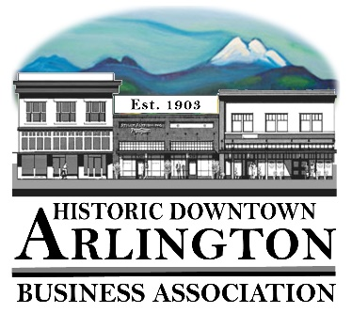
Downtown Arlington Business Association Board Meeting Agenda
August 15, 2018
5:15 – 6:15 pm
Location: Olympic Escrow

- Board Quorum verified and Meeting Called to Order
( Lisa ___Tina____Brandon___Cristy___Bill___Rich___)
Guests:

- Approval of Board Meeting Minutes Held June 20, 2018
Motion to Approve Minutes of the June 20, 2018 by_______ Seconded_____ All in Favor _____
- Communication, Meeting Schedules etc.,
    - A Night on the Town – Thursday August 16, 2018 4PM to 7:30PM
    - Presentation to Stilly Sr Center Food Bank $500.00 check-
Friday August 17 at 11:30
    - Friday August 17, 2018 at Noon
Presentation and Drawing of Prizes from
Thursday’s Night on the Town at the BPAC
    - Mainstreet Meeting – August 21 @ 11:30A
    - LTAC Training in City Council Chamber – 2PM August 22
    - Chamber Board Meeting – 7:30AM August 28th
    - Member Meeting September 5 – Draft Agenda Attached
- How can we get more people attending?
  - Appt. through Google Calendar?
  - More Reminders
  - Reminder Notice every week – Mailed reminders
- Raffles
- When introductions are made – make it a 1-minute commercial for your business.
- Time? Day?
- Speakers? Did we want to invite Joe Helland from Hibu – the guy Mike Britt Sent to you about websites?
- Training?
- Sign up for helping on Committees

Agenda Approved for September 5 meeting as is or with changes –
Notes:

    - September 8/9 Art in Legion Park
    - September 15, 2018 – Chamber Farm to Table Dinner
    - October 20 – Fall into Art Auction - Tickets are $40 each
- New Business:
  - Arlington Co-Working Space Update and discussion of how DABA will participate.
  - 2018 LTAC Reimbursements
  - 2019 LTAC Grants –
    - Street Fair – Advertising & Street Entertainment
    - Car Show – Advertising & Entertainment (Maybe add Radio like Street Fair Had)
    - Brochure – 2019 Distribution Costs and update in fall of 2019. Printing and Distribution in 2020
    - Hometown Holidays – Entertainment (Wagon Rides, Music??) & Advertising – Maybe add Radio Station?
    - Eagle Festival – Wagon Rides for 1-day Event? Charm walk?
  - 2019 Elections
  - 2018 Budget Reports
  - 2019 Budget – Suggestions, items to be included and/or deleted

- Old Business:
  - Sound System
Notes:

- Event/Project Reports:
  - 530 Media Board- they have converted our account to monthly, so we pay $1900.00 every month for two full slots. We currently have space available for September if anyone is interested. Cristy will start marketing for the final ¼ of 2018 – Oct,Nov,Dec at the rate of $400.00 per Business. Billing on the ¼ - but we can pay monthly.
Notes:
  - Car Show 2018 –
Notes:
  - Street Fair 2018- Johnny Green and the Pack String would like to hold their Kornstalk Event that same weekend and that would eliminate ours & City’s cost for entertainment for the Friday and Saturday of the Street Fair Weekend. We would only need entertainment on Sunday and we think that the Old Time Fiddlers and the Voices of the Village would be good entertainment for that day. We should invite Jeri to the next Board meeting to give us a formal report?
Notes:
  - A Night on the Town- August 16, 2018 from 4PM to 7:30PM – Passport cards and Downtown Brochures were delivered to SVGS to include in their goody bags on August 14th. Additional information has been distributed to merchants downtown.
  - New Fall Event
  - Hometown Halloween
  - Hometown Holidays – Kick off on November 24th with Shop Local/Holiday Open House and Tree Lighting
Notes:

- Treasurer/Administrator Report
  - Bank Account
  - Membership –

- Miscellaneous

Next Board Meeting –
Adjourn

